Real-time Accurate Optical Flow Sensor

Zhaoyi Wei, Dah-Jye Lee, and James K. Archibald
Dept. of Electrical and Computer Engineering, Brigham Young University
agouwin@et.byu.edu djlee@ee.byu.edu jka@ee.byu.edu

Abstract

An accurate real-time optical flow sensor implemented in FPGA is introduced in this paper. This sensor applies an optical flow algorithm based on ridge regression to solve the collinear problem existing in traditional least squares methods. A hardware structure is devised to accommodate ridge regression and temporal smoothing for gradient vector to improve optical flow accuracy. This motion sensor has been implemented in a customized embedded FPGA platform. It is capable of processing 60 320×240 images or 15 640×480 images per second. From experiments, it is shown that the proposed design achieves very high accuracy compared to other hardware-based designs.

1. Introduction

Compact embedded real-time optical flow sensor can be used for many computer vision tasks such as small unmanned autonomous vehicle navigation, vehicle collision detection, 3D reconstruction, and many other applications requiring standalone real-time motion estimation. Optical flow algorithms are widely used for motion estimation. Due to the high computational cost, traditional general purpose processors typically cannot meet the size, power and real-time requirements. GPUs can achieve very high calculation rates, but their power consumption is not acceptable for many unmanned vehicle applications. Specialized processors have been used but are slower than GPUs [1]. In recent years, many FPGA-based solutions have been proposed to resolve this issue. Customized hardware logics are designed to calculate optical flow in pipelined hardware structure in order to achieve real-time processing [2]-[7].
FPGA-based solutions can achieve much higher processing speed than software-based solutions, but are usually not as accurate. Using the Yosemite sequence as an example, a good software-based algorithm can achieve an angular error around 1° [8]. In comparison, the angular errors of FPGA-based designs are typically more than 10° [4, 7]. There are two main reasons for this performance difference. First, most state-of-the-art optical flow algorithms are software-oriented and not a good match for implementation using a hardware pipeline structure. Second, optical flow algorithms require strong smoothing to suppress noise in order to extract accurate motion information. The limited hardware resources available on most FPGA platforms do not allow proper smoothing compared to software.
Achieving the proper tradeoff between speed, efficiency and accuracy is critical to all hardware designs. Stronger smoothing suppresses noise but increases latency, utilizes more hardware resources and sometimes lowers processing speed. In this paper, two efforts are made to optimize speed and accuracy:
a) Ridge regression is applied to solve the collinear problem in the traditional least squares method at the cost of a small bias in the estimate.
b) A unique hardware structure is proposed in order to incorporate temporal smoothing which substantially increases the accuracy of the solution.
To the best of our knowledge, this optical flow sensor achieves the best accuracy to date on the Yosemite sequence compared to other published hardware-based designs.

2. Algorithm description

The brightness constancy assumption can be written as g(x+∆x,y+∆y,t+∆t)=g(x,y,t) where x, y are the spatial components, t is the temporal component. An equation regarding gradient components g_{x}, g_{y}, and g_{t} and velocity components v_{x} and v_{y} was derived [9]
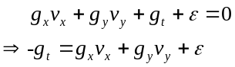 (1)
where v_{x}=∆x/∆t, v_{y}=∆y/∆t, and ε is the error representing the higher order terms and noise. Each pixel in the image has one set of observation {g_{ti,} g_{xi}, g_{yi}}. In a small local neighborhood of n pixels, it can be assumed that they all have the same velocity v_{x} and v_{y}. Then the n sets of observation for these n pixels can be expressed in a matrix form as
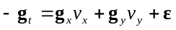 (2)
where g_{t}={g_{t1}, g_{t2}, …, g_{tn}}^{T}, g_{x}={g_{x1}, g_{x2}, …, g_{xn}}^{T}, g_{y}={g_{y1}, g_{y2}, …, g_{yn}}^{T}, ε ={ε₁, ε₂, …, ε_{n}}^{T}. It is assumed that E(ε_{i})=0 and variance is σ² i.e. ε_{i}~(0, σ²). Denote Y^{nx1}=-g_{t}, X^{nx2}=(g_{x,} g_{y}), θ^{2x1}=(v_{x}, v_{y})^{T}, the equation regarding the observation {g_{ti,} g_{xi}, g_{yi}} and the parameter θ can be written in the matrix form as
Y=Xθ + ε (3)
A traditional least squares solution of θ in (3) is
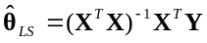. (4)
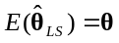and its covariance matrix is 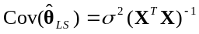. If g_{x} and g_{y} exhibit near linear dependency, i.e. one vector is nearly a scale of the other, small noise in the observation will cause large relative change in the inversion (X^{T}X)⁻¹ and produce very large and inaccurate motion vectors. For hardware-based algorithms, because of resource limitation, size n is usually smaller than software-based algorithms and increases the possibility of having a collinear X^{T}X matrix. Abnormal motion vectors will have a negative impact on neighboring motion vectors in the subsequent smoothing process.
Simply restricting the magnitude of a motion vector is not an optimal solution. In this paper, ridge estimator [10]-[12] as formulated in (5) is proposed to address this problem.
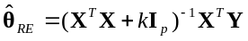 (5)
In (5), I_{p} is a unit matrix of the same size as X^{T}X where p equals 2 in this case. k is a weighting scalar for I_{p}. It is shown in [10] that the expectation and covariance matrices of 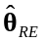 are
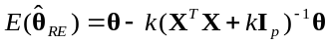 (6)
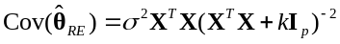 (7)
Although ridge estimator is biased, i.e. 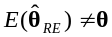 in (6), it is better than least squares estimator if measured with the risk instead of observed loss. Risk is defined as the expectation of loss which is independent of the observed Y. More details are shown in [10].
As to the selection of k, HKB estimator [13] is chosen: 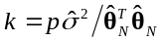. (8)
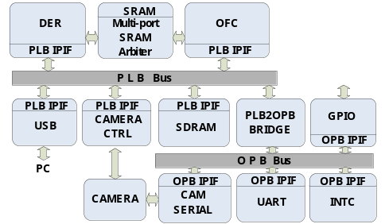
Figure 1 System diagram

In the content, 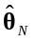 is the estimate right above current pixel and it is preset to (1,1)^{T} on the first row. Error variance is estimated as
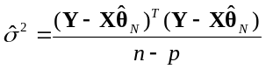 (9)
There exist other methods to estimate the scalar e.g. iterative HK estimator [14], LW estimator [15] and etc. HKB estimator is chosen for its efficiency and non-iterative property for hardware implementation. After obtaining k, optical flow is estimated using (5).
In real implementation, an n×n weighting matrix W is used to assign weights to each set of observation based on their distance to the central pixel. Equations (5) and (9) are rewritten as
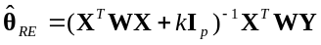, (10)
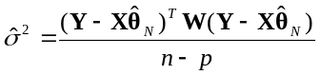. (11)
To suppress noise, gradient components g_{x}, g_{y}, and g_{t} are spatio-temporally smoothed respectively before they are used in (2). Motion vectors are also spatially smoothed to obtain a smoother motion field.
The proposed algorithm is not iterative and can be pipelined. It only needs simple arithmetic operations which are ideal for hardware implementation.

3. Sensor System Design

The proposed compact optical flow sensor is an embedded vision system including video capture, processing, transferring and other functionalities. Various modules are connected to the buses as shown in Fig. 1. There are two types of buses in the system: PLB bus and OPB bus. The PLB bus connects high speed modules such as DER module (DERivatives calculation), OFC module (Optical Flow Calculation), SDRAM, camera and USB modules. Lower speed modules such as UART, interrupt controller, and GPIO are connected to the OPB bus. The PLB and OPB buses are interconnected through a bridge.
Data flow in the system is directed by software running on built-in PowerPC processors. The DER module is triggered when a new image frame is captured by the camera and has been stored in SDRAM. After processing, results from the DER module are stored in SRAM and SDRAM. The DER and OFC modules share the high-speed SRAM through a multi-port SRAM arbiter. The OFC module then processes the intermediate results and stores the resulting motion vectors in SDRAM. The intermediate or final results can be transferred to the host PC through the USB interface. A graphical user interface has been developed to observe and store the video and display status variables transferred from the sensor.
The DER module diagram is shown in Fig. 2. It calculates the derivative frames g_{x}, g_{y}, g_{t} from raw images. To obtain a suitable tradeoff between accuracy and efficiency, mask D=(1,−8,0,8,−1)/12 is used to calculate the derivatives. To calculate g_{t,} frame(t), frame(t-1), frame(t-3), frame(t-4) are used. frame(t-2) is used to calculate g_{x} and g_{y}. The results are stored both in SRAM and SDRAM. The reason for storing the derivative frames in both memories is that derivative frames are temporally smoothed in the OFC module and there’s not enough space to store the intermediate results in the hardware pipeline.
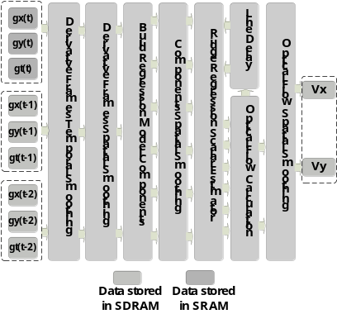
Figure 3 OFC module

The OFC module diagram is shown in Fig. 3. Derivative frames read into the hardware pipeline are temporally smoothed and then spatially smoothed. These smoothed derivatives frames are combined to build ridge regression model components. These components are spatially smoothed and then fed into the scalar estimator in (8) and (11) to calculate scalar k. Optical flow can then be calculated with the scalar k and the smoothed regression model components as in (10). The optical flow vector is buffered to be lined up with the pixel right below on the next row in order to calculate k. The optical flow vector is then spatially smoothed to obtain the final optical flow vector.
In the OFC module, the size of the temporal smoothing window is three which means three sets of derivative frames need to be stored. Besides temporal smoothing, there are three spatial smoothing units: derivative frames spatial smoothing, regression model components spatial smoothing, and optical flow spatial smoothing. Parameters of these smoothing masks are in the shape of a 2D Gaussian function and their mask sizes are 5×5, 3×3, and 7×7 respectively. The configurations of these masks were evaluated carefully in software before implementation to achieve an optimal tradeoff between accuracy and efficiency.
To accommodate temporal smoothing, the hardware pipeline is divided into two parts (DER, OFC) because the derivative frames are too big to be stored in the pipeline itself. A drawback of this scheme is the increase in the memory throughput required and the resulting decrease in processing speed. However, as long as these modules are able to keep up with the camera frame rate, temporal smoothing can substantially improve the accuracy without impacting real-time performance.

4. Experiment Results

The design was implemented on the Helios FPGA platform [16]. This platform is equipped with a Virtex-4 FX60 FPGA which has two PowerPC processors in addition to configurable logic resources. The system runs at 100 MHz. The camera core is set to output 640×480 images at 15 fps or 320×240 images at 60 fps depending on the application. For debugging and evaluating purposes, a bit-level accurate MATLAB simulation code was programmed to match the hardware circuit.
Fig. 4 shows the effect of ridge regression tested on the lower part of the Yosemite sequence. Fig. 4(a) shows the result using the least squares method. Fig. 4(b) shows the result using the proposed ridge regression method. It can be seen that these two algorithms perform comparably on the right half of image which has abundant textures. On the left half which does not have many distinguishable textures, the ridge regression based method generates smoother results compared to the least squares method (fewer spurious vectors) under the same smoothing settings.
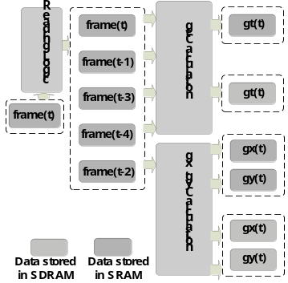
Figure 2 DER module
Table 1 shows the simulated accuracies on the Yosemite sequence under different settings. The accuracies are measured in angular error. A₁ is the accuracy of the proposed design (using ridge regression and temporal smoothing). A₂ is the accuracy using the least squares method with temporal smoothing. A₃ is the accuracy using ridge regression without applying temporal smoothing. A₄ is the accuracy using least squares method without applying temporal smoothing. Fig.(5) shows the test results on the Yosemite, flower garden, SRI tree, and BYU corridor sequences. The proposed design works very well on these sequences.
Table 1 Accuracies comparison
A₁ | A₂ | A₃ | A₄
6.8° | 7.2° | 10.9° | 11.4°

5. Conclusions and Future Work

An accurate optical flow algorithm implemented in an embedded motion sensor is discussed in this paper. To minimize the problem of deficient smoothing in hardware-base designs, ridge regression is applied to avoid abnormal motion vectors. A new hardware structure is devised to incorporate temporal smoothing. These efforts substantially improve the accuracy.
Future work will include using real-time optical flow for small unmanned vehicle navigation tasks such as obstacle avoidance and ego motion estimation. Motion information will be fed into the control loop to help make control decisions.

References

[1] M. Correia, A. Campilho. Real-time implementation of an optical flow algorithm, Proc. ICPR, 4:247-250, 2002.
[2] A. Zuloaga, J. L. Martín, J. Ezquerra. Hardware architecture for optical flow estimation in real time. Proc. ICIP, 3:972-976, 1998.
[3] J. L. Martín, A. Zuloaga, C. Cuadrado, J. Lázaro, U. Bidarte. Hardware implementation of optical flow constraint equation using FPGAs. Computer Vision and Image Understanding, 98:462-490, 2005.
[4] J. Díaz, E. Ros, F. Pelayo, E. M. Ortigosa, S. Mota. FPGA-based real-time optical-flow system. IEEE Trans. Circuits and Systems for Video Technology, 16(2): 274-279, February 2006.
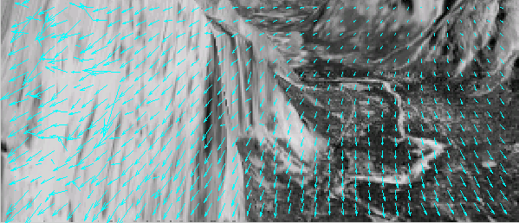(a)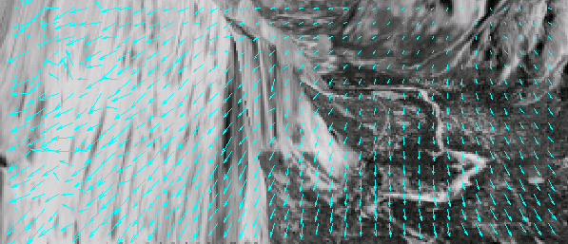(b)
Figure 4 Performance improvement using ridge regression

[5] P. C. Arribas, F. M. H. Maciá. FPGA implementation of camus correlation optical flow algorithm for Real Time Images. 14th Int. Conf. Vision Interface, 32-38, 2001.
[6] H. Niitsuma, T. Maruyama. High speed computation of the optical flow. Lecture notes in Computer Science, 3617:287-295, 2005.
[7] Z.Y. Wei, D.J. Lee, B. Nelson, M. Martineau. A Fast and Accurate Tensor-based Optical Flow Algorithm Implemented in FPGA. IEEE WACV, p18, 2007.
[8] G. Farnebäck, “Very high accuracy velocity estimation using orientation tensors, parametric motion, and simultaneous segmentation of the motion field”, Proc. ICCV, vol. 1, pp. 77–80, 2001.
[9] B. Horn, B. Schunck, “Determining optical flow”, Artificial Intelligence, vol. 17, pp. 185-203, 1981.
[10] Jürgen Groß. Linear Regression. Lecture Notes in Statistics 175. Springer-Verlag, Berlin, Heidelberg, 2003.
[11] A. Hoerl, R. Kennard. Ridge regression. Biased estimation for nonorthogonal problems, Technometrics, 12(1):55-67, 1970.
[12] D. Comaniciu. Nonparametric Information Fusion for Motion Estimation. Proc. CVPR, 1:59-66, June, 2003.
[13] A. Hoerl, R. Kennard, K. Baldwin. Ridge regression: some simulations. Communications in Statistics, Theory and Methods, 4:105-123, 1975.
[14] A. Hoerl, R. Kennard. Ridge regression iterative estimation of the biasing parameters. Communication in Statistics, Theory and Methods, 5:77-88, 1976.
[15] J. Lawless, P. Wang. A simulation study of ridge and other regression estimators. Communications in Statistics, Theory and Method, 5:307-323, 1976.
[16] http://www.ece.byu.edu/roboticvision/helios/
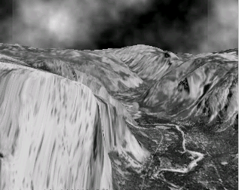(a)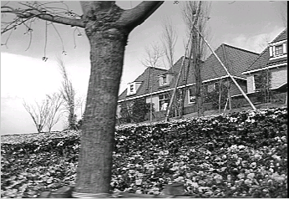(b)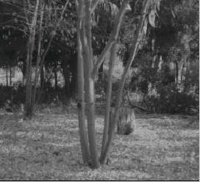(c)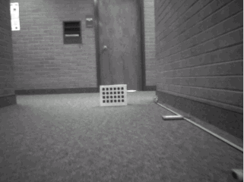(d)
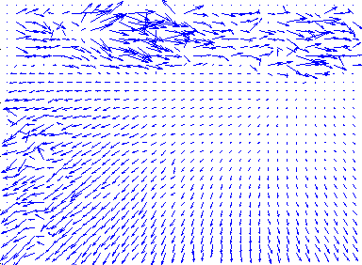(e)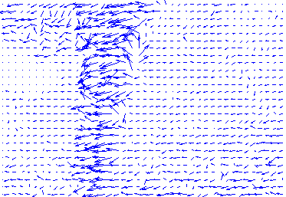(f)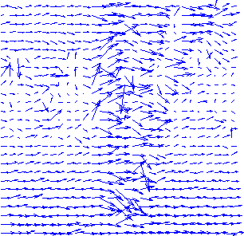(g)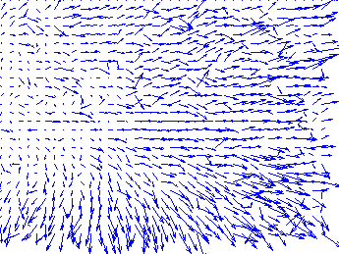(h)
Figure 5 Experiment results

